***AIDS MICROPROCESSOR LAB S21 BATCH (2023-24)***

***Experiment 9 Title: Assembly language programming TO DISPLAY THE CHARACTERS '*' FIVE TIMES AT CURSOR POSITION SET TO ROW 5,COLUMN 15 using INT 10H***

***Name of student: Meet Raut Class Roll Number: 2201084***

***Date of Performance: 18/03/2024***

***Batch: S2-1 Timing: 3:00-5:00 Date of Submission: 18/03/2024***

***Assembly language code***

*DATA_SEG SEGMENT*

*ROW DB 5*

*COL DB 15*

*CHAR DB '*'*

*DATA_SEG ENDS*

*CODE_SEG SEGMENT*

*ASSUME CS:CODE_SEG,DS:DATA_SEG*

*START:*

*MOV AX,DATA_SEG #INITIALISE THE DATA SEGMENT REGISTER*

*MOV DS,AX*

*MOV BH,0 #SET PAGE TO 0(BH DISPLAY PAGE NUMBER)*

*MOV DH,ROW #SET ROW POSITION*

*MOV DL,COL #SET COLUMN POSITON*

*MOV AH,02 #SET CURSOR POSITION*

*INT 10H*

*MOV CX,5*

*MOV AL,CHAR #ASCII CODE OF THE CHRACTERS TO BE . DISPLAYED*

*MOV BL,2EH #2=010(GREEN),E=1110(YELLOW)*

*MOV BL,0AEH #BLINKING*

*MOV BH,0*

*MOV AH,09H #FUNCTION USED TO DISPLAY STRING OF . CHARACTERS*

*INT 10H*

*MOV AH,4CH #REQUEST TO TERMINATE*

*INT 21H #EXIT TO DOS*

*CODE_SEG ENDS*

*END START*

*Result:*

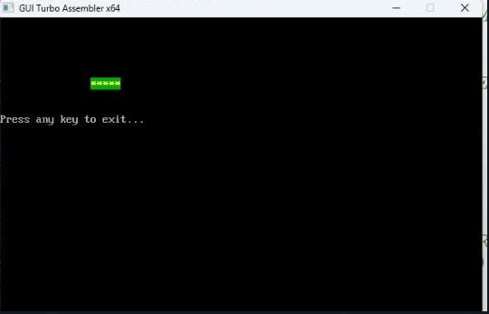

*CONCLUSION: LO 2, LO 3 mapped.*

***---------------------------------*****************************-----------------------------------***